The following figure shows an example of:

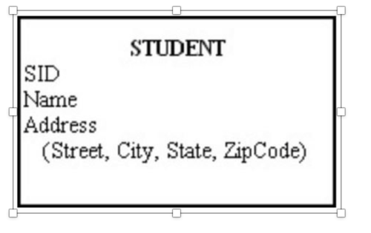

A) a composite attribute.  
B) a relational attribute.  
C) a derived attribute.  
D) a multivalued attribute.

Step 1: Answer with Explanation

a composite attribute.

Simple qualities are those that cannot be further broken down into smaller components. Composite qualities are those that can be further broken down into smaller components.

Step 2: Explanation for incorrect option

Each relationship type might have its own set of relationship qualities. In order to create features or qualities that further define relationships, attributes are offered. For instance, you might want to use attributes to specify the type of relationship in a conventional setting like counselling.

An attribute is said to be derived if its value can be inferred from the values of other attributes, in which case it is said to be derivable.

An entity's multivalued attributes are those that have more than one value connected to the entity's key. For instance, a big business could have a lot of divisions, some of which possibly in different cities.

In the figure below, Name would be an ideal identifier. True or false

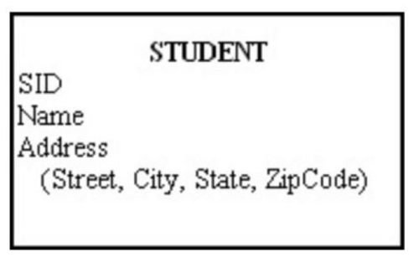

Step 1: Answer:

False

Step 2: Explanation

In contrast to language keywords or commands, an identifier is the representation of items created by the user within the language. Some identifiers refer to dictionary objects, which are the objects you build and store in a database, including tables, views, indexes, columns, and constraints.

A database object's name is a SQL identifier. Examples of items with SQL identifiers are the following: tables, columns, views, indexes, synonyms, and stored procedure names are examples of database schema components. IBM Informix® ESQL/C structures that are dynamic, like cursors and statement IDs.